**EXPLORATION OF NEW CITIES**

A Research Project Report Submitted to

**JAWAHARLAL NEHRU TECHNOLOGICAL UNIVERSITY, HYDERABAD**

In Partial Fulfilment of the requirement for the Award of the Degree of

**BACHELOR OF TECHNOLOGY**

**In**

**COMPUTER SCIENCE AND DESIGN**

**Submitted by**

**1.N. Sathwika (H.T.NO:22N01A7448)**

**2.V. Madhusha (H.T.N0:22N01A7760)**

**3.M. Akshaya (H.T.N0:22N01A7421)**

**4.M. Shivamani (H.T.NO:22N01A7450)**

**5.Suzzain Siddiq (H.T.NO:22N01A7413)**

Under the Supervision of

**K. SHRAVANI**

**Assistant Professor**



**Department of Computer Science and Engineering**

**SREE CHAITANYA COLLEGE OF ENGINEERING**

(Affiliated to JNTUH, HYDERABAD)

THIMMAPUR, KARIMNAGAR, TELANGANA-505 527

**SREE CHAITANYA COLLEGE OF ENGINEERING**



(Affiliated to JNTUH, HYDERABAD)

THIMMAPUR, KARIMNAGAR, TELANGANA-505 527

**Department of Computer Science and Design**

**CERTIFICATE**

This is to certify that the Real-Time Research project report entitled **“Exploration of New Cities”** isbeing submitted by **N. Sathwika, V. Madhusha, M. Akshaya, M. Shivamani, Suzzain Siddiq** bearing hall ticket numbers: **22N01A7448, 22N01A7460, 22N01A7421, 22N01A7450, 22N01A7413 ,**for partial fulfillment of the requirement for the award of the degree of **Bachelor of Technology** in **Computer Science and Design** discipline to the **Jawaharlal Nehru Technological University, Hyderabad** during the academic year 2023 - 2024 is a bona fide work carried out by him under my guidance and super vision.

The result embodied in this report has not been submitted to any other University or institution for the award of any degree of diploma.

## Project Guide Head of the Department

## K. SHRAVANI K.SRIKANTH REDDY

## Assistant Professor Associate Professor

## Department of CSD Department of CSD

**i**

**SREE CHAITANYA COLLEGE OF ENGINEERING**



(Affiliated to JNTUH, HYDERABAD)

THIMMAPUR, KARIMNAGAR, TELANGANA-505 527

**Department of Computer Science and Design**

**DECLARATION**

**We, N. Sathwika**, V. Madhusha, M. Akshaya, M. Shivamani, Suzzain Siddiq are students of **Bachelor of Technology in Computer Science and Design ,**during the academic year:2023-2024**,**hereby declare that the work presented in this Project Work entitled **Exploration of New Cities** is the outcome of our own bona fide work and is correct to the best of our knowledge and this work has been undertaken taking care of Engineering Ethics and carried out under the supervision of **K.SHRAVANI ,Assistant Professor**.

It contains no material previously published or written by another person nor material which has been accepted for the award of any other degree or diploma of the university or other institute of higher learning, except where due acknowledgment has been made in the text.

**1.N. Sathwika (H.T.NO:22N01A7448)**

**2.V. Madhusha (H.T.N0:22N01A7760)**

**3.M. Akshaya (H.T.N0:22N01A7421)**

**4.M. Shivamani (H.T.NO:22N01A7450)**

**5.Suzzain Siddiq (H.T.NO:22N01A7413)**

## Date:

**Place:**

ii

**SREE CHAITANYA COLLEGE OF ENGINEERING**



(Affiliated to JNTUH, HYDERABAD)

THIMMAPUR, KARIMNAGAR, TELANGANA-505 527

**Department of Computer Science and Design**

**ACKNOWLEDGEMENTS**

The Satisfaction that accomplishes the successful completion of any task would be incomplete without the mention of the people who make it possible and whose constant guidance and encouragement crown all the efforts with success.

We would like to express our sincere gratitude and indebtedness to our project supervisor ***K. Shravani, Assistant Professor***, Department of Computer Science and Design, Sree Chaitanya College of Engineering, LMD Colony, Karimnagar for his/her valuable suggestions and interest throughout the course of this project

We also thankful to Head of the department ***Mr. K. Srikanth Reddy***, Department of Computer Science and Design, Sree Chaitanya College of Engineering, LMD Colony, Karimnagar for providing excellent infrastructure and a nice atmosphere for completing this project successfully

We Sincerely extend out thanks to ***Dr.G.Venkateswarlu ,Principal*** Sree Chaitanya College of Engineering, LMD Colony ,Karimnagar ,for providing all the facilities required for completion of this project.

We convey our heartfelt thanks to the lab staff for allowing us to use the required equipment whenever needed.

Finally, We would like to take this opportunity to thank our family for their support through the work.

We sincerely acknowledge and thank all those who gave directly or indirectly their support in completion of this work.

***N. Sathwika***

***V. Madhusha***

***M. Akshaya***

***M. Shivamani***

***Suzzain Siddiq***

iii

**EXPLORATION OF NEW CITIES**

**ABSTRACT**

Most of the people in this world like to travel from one place to another no matter whether it is a small or large distance. The need for a tourism management system that can manage tourism information with ease is sought after by every tour management company. Tour Management system is a dynamic website for tourism business. This tourism application is designed for travel agencies by which they can manage different tour packages based on the destinations. By using this, the tour company can tailor tour packages spanning various destinations at almost every price point. The also implemented search module allows the administrator to find and update or upgrade the tour packages with ease. This module can also even be extended to a customer application page by which customers can find the right tour package for them at every budget, depending on the tour locations. The main purpose is to help tourism companies to manage tour packages. The system can also be used for both professional and business trips. The proposed system maintains a centralized repository to make necessary travel arrangements and to retrieve information easily. Exploring new cities can be an exhilarating experience filled with discoveries and opportunities to learn about diverse cultures, histories, and geographies. The rise of technology has paved the way for innovative methods to facilitate city exploration. Tours and Travel Management System is a web-based application. The main purpose of “Tours and travels management system” is to provide a convenient way for a customer to book hotels, flight, train and bus for tour purposes. In this project, We will make an easier task of searching places and for booking train, flight or bus. In the present system a customer has to approach various agencies to find details of places and to book tickets. This often requires a lot of time and effort. We provide approach skills to critically examine how a tourist visits and its ability to operate in an appropriate way when dealing with the consequences of tourism, locally, regionally, and nationally including visitor security and ecological influences. It is tedious for a customer to plan a particular journey and have it executed properly. The project ‘Tours and Travels Management System’ is developed to replace the currently existing system, which helps in keeping records of the customer details of destination as well as payment received.

iv

**TABLE OF CONTENTS**

**CHAPTER NO TITLE PAGE NOS.**

Certificate ..........................................................................................................................................................i

Declaration .........................................................................…………………………..…………………..……….ii

Acknowledgements ......................................................................................................................................iii

Abstract...............................................................................................................................................................iv

Table of Contents.............................................................................................................................................v

**1 INTRODUCTION 01-06**

1.1. Overview

1.3. Existing System

1.4. Proposed System

1.5. Objective

**2 LITERATURE SURVEY 07-08**

**3 PROBLEM DEFINITION 09**

**4 SOFTWARE AND HARDWARE REQUIREMENTS 10-13**

4.1. Introduction

4.2. Purpose

4.3. Functional Requirements

4.4. Non Functional Requirements

4.5. Input and Output Design

4.6. Hardware Requirements

4.7. Software Requirements

**5 SYSTEM DESIGN 14-23**

**5.1. System specifications**

Requirement analysis

Requirement specification

Functional Requirements

Software Requirements

Debugger and Emulator

Hardware Requirements

v

**5.2. System Architecture**

**5.3. UML Diagrams**

Class Diagram

Use Diagram

Sequence Diagram

Activity Diagram

Component Diagram

Package Diagram

Profile Diagram

**5.4. ER DIAGRAM**

1. **IMPLEMENTATION 24-25**

System Components

Technical Requirements

Additional Features

1. **TECHNOLOGY DISCRIPTION 26-31**
2. **CODING 32-33**

Source Code

1. **SYSTEM TESTING 34-35**
   1. **Testing Methodologies**
   2. **Types of Tests**

Unit Testing

Integration Testing

**10 RESULT AND OUTPUT SCREENS 36-38**

**11 CONCLUSION AND ENHANCEMENT 39**

**12 REFERENCES 40-41**

vi

**CHAPTER-1**

**INTRODUCTION**

* 1. **OVERVIEW:**

Exploring new cities opens up a world of discovery, blending history, culture, and adventure into an

immersive experience. Each city is a unique tapestry woven with its own tales, architecture,

and people. As travelers, we embark on journeys not just to see sights but to feel the pulse of a new place,

to taste its cuisine, and to connect with its essence.

The allure of exploring new cities lies in the promise of encountering the unexpected. Every turn of a

corner may reveal a hidden gem—an ancient temple steeped in legends, a bustling market fragrant with spices,

or a quiet café where locals gather to share stories. These moments capture the essence of travel: the

joy of exploration and the thrill of the unknown.

Beyond mere sightseeing, exploring a new city is an invitation to delve into its history. Walking through

cobblestone streets that have witnessed centuries of events, one can sense the layers of time that have

shaped the city's identity. From grand palaces that once housed royalty to humble neighborhoods that

breathe the spirit of community, each part of the city tells a story waiting to be discovered.

Moreover, the cultural tapestry of a city unfolds through its art, music, and traditions. Museums display

masterpieces that reflect the soul of a civilization, while theaters resonate with the echoes of performances that

have enthralled audiences for generations. Festivals bring streets to life with colors and rhythms, offering a

glimpse into the celebratory spirit of its people.

Exploration also encompasses the culinary journey—a delightful exploration of flavors and aromas.

Whether savoring street food in vibrant markets or dining in Michelin-starred restaurants, each meal tells a

tale of local ingredients, traditions, and craftsmanship. Food becomes a gateway to understanding a city's

heritage and the passions of its residents.

Equally enriching is the opportunity to connect with locals. Conversations in cafes, interactions in

01

markets, or joining in local festivities provide insights into everyday life and foster genuine connections.

These encounters transcend language barriers, bridging cultures through shared experiences and mutual

curiosity.

Yet, amidst the excitement of exploration, there is also contemplation. Standing atop a hill to gaze at a

sprawling cityscape or strolling along a riverbank at sunset, one finds moments of serenity and reflection.

These are the pauses that allow travelers to absorb the essence of a place, to ponder its contrasts, and to

appreciate its beauty in quietude.

In essence, exploring new cities is a journey of self-discovery as much as it is about discovering a new

place. It challenges perspectives, broadens horizons, and encourages a deeper understanding of the world.

Each city visited leaves an indelible mark—a mosaic of memories that shapes our own narrative of

travel and adventure.

02

* 1. EXISTING SYSTEM

The existing tour and travel management systems leverage a blend of advanced technological solutions and streamlined operational processes to cater to diverse customer needs and industry demands. These systems typically incorporate robust booking engines that facilitate seamless reservation and itinerary management across multiple platforms, including websites and mobile applications. Integration with global distribution systems (GDS) ensures real-time availability of flights, accommodations, and tour packages, enhancing efficiency and accuracy in booking procedures. Customer relationship management (CRM) tools play a pivotal role in maintaining personalized interactions and managing customer preferences, thereby fostering enhanced customer satisfaction and loyalty. Operational functionalities encompass resource allocation, inventory management, and logistical planning, optimized through data-driven analytics and forecasting algorithms. Compliance with regulatory standards and data security protocols ensures the safeguarding of sensitive information and adherence to industry best practices. Overall, existing tour and travel management systems embody a sophisticated ecosystem of technology, operations, and customer-centric strategies aimed at delivering seamless travel experiences and driving organizational growth in a competitive market landscape.

Drawbacks:

Implementing a comprehensive system can be costly, requiring investment in software, hardware, and training. Integration with existing IT infrastructure and customization to specific business needs may also pose challenges.

Reliance on technology means systems are vulnerable to technical failures, cybersecurity threats, or disruptions in internet connectivity, potentially impacting service delivery and customer experience.

Some customers, particularly older demographics or those unfamiliar with digital platforms, may find it challenging to adapt to online booking systems or prefer traditional methods, leading to resistance and potential loss of business.

Managing sensitive customer data requires robust cybersecurity measures to protect against data breaches and comply with privacy regulations (e.g., GDPR), which can be complex and resource-intensive.

Regular maintenance, updates, and system upgrades are necessary to ensure optimal performance and compatibility with evolving technologies and industry standards, requiring ongoing investment of time and resources.

03

While automation enhances efficiency, excessive reliance may diminish personalized customer interactions, reducing the human touch and potentially impacting customer satisfaction.

Integrating diverse systems (e.g., booking engines, CRM, GDS) from different vendors can be complex, leading to compatibility issues, data synchronization problems, and delays in system deployment or updates.

Navigating complex legal and regulatory frameworks across different regions or countries requires continuous monitoring and adaptation, adding to operational complexity and potential legal risks.

1.3: PROPOSED SYSTEM

Proposing an advanced tour and travel management system involves leveraging cutting-edge technologies and streamlined processes to enhance operational efficiency and customer satisfaction. The proposed system will integrate a user-friendly interface with mobile responsiveness, enabling travelers to easily browse, book, and manage their itineraries from any device. Key features will include real-time updates on availability, pricing, and promotions through seamless integration with global distribution systems (GDS) and online booking platforms. Personalization algorithms will tailor recommendations based on customer preferences and past behaviur, fostering greater engagement and loyalty. Advanced analytics will provide insights into booking trends, customer demographics, and service performance, facilitating data-driven decision-making and proactive resource management. Security measures will encompass robust data encryption, secure payment gateways, and compliance with stringent data protection regulations to safeguard customer information. Continuous system monitoring and regular updates will ensure optimal performance and scalability to meet evolving industry demands. By prioritizing efficiency, innovation, and customer-centricity, the proposed system aims to set a new standard in tour and travel management, enhancing competitiveness and driving sustained growth in the dynamic travel market.

Advantages:

The system's intuitive interface and mobile compatibility empower users to effortlessly browse, book, and manage travel arrangements from any device, ensuring convenience and accessibility.

Integration with GDS and online booking platforms streamlines reservation processes, reducing manual effort and enhancing booking accuracy. Real-time updates on availability and pricing optimize decision-making and responsiveness.

04

Advanced algorithms personalize recommendations based on customer preferences and past interactions, fostering deeper engagement and increasing customer satisfaction and loyalty.

Robust analytics provide valuable insights into booking patterns, customer behaviour, and market trends, enabling informed decisions on pricing strategies, inventory management, and service enhancements.

The system's architecture supports scalability to accommodate growing business needs and fluctuations in demand. Cloud-based infrastructure facilitates seamless updates and expansions without disrupting operations.

Rigorous security protocols, including data encryption and secure payment gateways, ensure the

protection of sensitive customer information. Compliance with data protection regulations (e.g., GDPR) enhances trust and mitigates legal.

Automation of repetitive tasks and optimized resource allocation reduce operational costs while maximizing efficiency. This allows for better allocation of resources towards improving service quality and customer experiences.

By offering superior user experiences, personalized services, and efficient operations, the proposed system positions businesses competitively in the dynamic travel industry, attracting and retaining a loyal customer base

05

1.4: OBJECTIVE

This application is developed to provide best travelling services to the customers and travel agents. We have developed tours and travel management system to provide a search platform where a tourist can find their tour places according to their choices. This system also helps to promote responsible and interesting tourism so that people can enjoy their holidays at their favourable places. This system also helps to develop tourism with different cultures so that they enrich the tourism experience and build pride. We develop this system to create and promote forms of tourism that provide healthy interaction opportunities for tourists and locals and increase better understanding of different cultures, customs, lifestyles, traditional knowledge and believes. This system also provides a better way to connect with various events. This system also gives tours related information like which places are tourist attractions, cities, and provinces. Tourist can also get the Map and navigation system and temperature and weather information. Tourist can also book tours through our tours and travels management system. This system also keeps a history of visited places of its users.

06

CHAPTER-2

LITERATURE SURVEY

Early systems relied heavily on manual processes for booking, scheduling, and customer management. With the advent of digital technology, there has been a shift towards automated systems that integrate online booking platforms, customer relationship management (CRM) software, and real-time updates.

The literature highlights the incorporation of AI, machine learning, and big data analytics in tour and travel management. These technologies enhance personalized recommendations, predictive analytics for demand forecasting, and optimization of travel routes.

emphasize the importance of enhancing customer experience through user-friendly interfaces, mobile applications, and 24/7 customer support. Personalization through data analytics plays a crucial role in tailoring services to individual preferences.

Efficient resource allocation, route optimization, and inventory management are key areas of focus. Literature discusses how advanced systems help in reducing operational costs while improving service delivery.

Challenges such as data security, regulatory compliance, and integration with existing IT infrastructure are discussed. Solutions involve adopting scalable cloud-based solutions, robust cybersecurity measures, and adherence to industry standards.

The survey covers global trends such as the rise of eco-tourism, sustainable travel practices, and the impact of geopolitical factors on travel management systems. Market dynamics include the growth of online travel agencies (OTAs) and their role in shaping consumer behavior.

Literature points towards future directions like virtual reality (VR) for immersive travel experiences, blockchain for secure transactions, and the Internet of Things (IoT) for real-time monitoring of travel assets.

Mobile applications have revolutionized the travel industry by providing travellers with instant access to booking, itinerary management, and real-time updates. Studies highlight the significance of mobile-friendly interfaces and the seamless integration of services like GPS navigation and digital payments.

Big data analytics enables tour operators to gather and analyse vast amounts of customer data. This information is used to personalize marketing campaigns, improve customer segmentation, and forecast demand. Machine learning algorithms further enhance predictive analytics for pricing

07

strategies and resource allocation. Social media platforms and online review sites play a crucial role in shaping consumer decisions.

Literature discusses how tour operators utilize social media for marketing purposes, customer engagement, and reputation management. The analysis of online reviews helps in understanding customer feedback and improving service quality.

There is a growing emphasis on sustainability and responsible tourism practices within tour and travel management systems. Studies explore initiatives such as eco-friendly accommodations, carbon footprint reduction strategies, and community-based tourism projects. Integration of sustainability metrics into management systems is becoming increasingly important.

The literature addresses regulatory challenges faced by tour operators, such as compliance with local and international laws, data protection regulations (e.g., GDPR), and safety standards. Effective management systems incorporate legal frameworks to ensure operational transparency and consumer protection.

The expansion of tour and travel management systems into emerging markets is a notable trend. Literature discusses the adaptation of technology to meet the unique needs of diverse cultural and economic environments. Globalization trends also highlight the importance of cross-border collaborations and partnerships.

Effective implementation of tour and travel management systems requires trained personnel proficient in technology and customer service. Studies explore training programs and skill development initiatives aimed at enhancing workforce capabilities in areas such as digital marketing, IT management, and customer relationship management.

The literature emphasizes the significance of customer retention strategies and loyalty programs within tour and travel management. Case studies demonstrate the effectiveness of personalized offers, rewards programs, and CRM systems in fostering long-term customer relationships and enhancing repeat business.

In summary, a comprehensive literature survey on tour and travel management systems delves into the integration of mobile technology, big data analytics, sustainability practices, regulatory compliance, globalization trends, workforce development, and customer retention strategies. These aspects collectively shape the evolving landscape of the travel industry and inform future advancements in management systems.

08

CHAPTER-3

PROBLEM DEFINITION

The problem definition in tour and travel management systems revolves around addressing various challenges and inefficiencies that hinder operational effectiveness and customer satisfaction. Key issues include:

Existing systems may lack user-friendly interfaces or integration with global distribution systems (GDS), leading to cumbersome booking processes and potential errors in reservation management.

Many systems fail to provide personalized recommendations and tailored travel experiences based on customer preferences, impacting customer satisfaction and loyalty.

Poor coordination of resources such as transportation, accommodations, and tour guides can lead to overbooking, underutilization of assets, and increased operational costs.

Handling sensitive customer information without robust security measures poses risks of data breaches and non-compliance with data protection regulations (e.g., GDPR), potentially damaging trust and reputation.

Outdated technology infrastructure may hinder scalability, agility, and the ability to adapt to evolving market trends and customer expectations.

Inadequate customer support mechanisms, including lack of real-time communication channels and 24/7 assistance, can lead to dissatisfaction and negative feedback.

Difficulty in integrating disparate systems (e.g., booking engines, CRM platforms, payment gateways) from different vendors can result in operational inefficiencies, data inconsistencies, and delays in service delivery.

With increasing focus on sustainable tourism practices and regulatory requirements, systems must incorporate measures to minimize environmental impact and ensure compliance with local and international regulations.

Addressing these challenges requires a comprehensive approach that combines technological innovation, customer-centric strategies, and adherence to regulatory standards. A robust tour and travel management system should aim to streamline booking processes, enhance personalization, optimize resource utilization, prioritize data security, facilitate seamless integration, improve customer service, and promote sustainability. By tackling these issues proactively, businesses can enhance operational efficiency, elevate customer satisfaction, and gain a competitive edge in the dynamic travel industry.

09

**CHAPTER – 4**

**SYSTEM REQUIREMENTS SPECIFICATION**

**4.1 Introduction**

**PYTHON**

Python is a general-purpose interpreted, interactive, object-oriented, and high-level programming language. An interpreted language, Python has a design philosophy that emphasizes code readability (notably using whitespace indentation to delimit code blocks rather than curly brackets or keywords), and a syntax that allows programmers to express concepts in fewer lines of code than might be used in languages such as C++or Java. It provides constructs that enable clear programming on both small and large scales. Python interpreters are available for many operating systems. Python, the reference implementation of Python, is open source software and has a community-based development model, as do nearly all of its variant implementations. Python is managed by the non-profit Python Software Foundation. Python features a dynamic type system and automatic memory management. It supports multiple programming paradigms, including object-oriented, imperative, functional and procedural, and has a large and comprehensive standard library

**4.2 Purpose**

The project involved analyzing the design of few applications so as to make the application more users friendly. To do so, it was really important to keep the navigations from one screen to the other well ordered and at the same time reducing the amount of typing the user needs to do. In order to make the application more accessible, the browser version had to be chosen so that it is compatible with most of the Browsers.

**4.3 Functional Requirements**

* Graphical User interface with the User.

**4.4 Non-Functional Requirements**

• **Maintainability:** Maintainability is used to make future maintenance easier, meet new requirements. Our project can support expansion.

• **Robustness:** Robustness is the quality of being able to withstand stress, pressures or changes in procedure or circumstance. Our project also provides it.

• **Reliability:** Reliability is an ability of a person or system to perform and maintain its functions in circumstances. Our project also provides it.

10

• **Size:** The size of a particular application plays a major role, if the size is less then efficiency will be high. The size of database we have developed is 5.05 MB.

• **Speed:** If the speed is high then it is good. Since the no of lines in our code is less, hence

the speed is high.

• **Power Consumption:** In battery-powered systems, power consumption is very important. In the requirement stage, power can be specified in terms of battery life.

**4.5 Input & Output Design**

**INPUT DESIGN**

The input design is the link between the information system and the user. It comprises the developing specification and procedures for data preparation and those steps are necessary to put transaction data in to a usable form for processing can be achieved by inspecting the computer to read data from a written or printed document or it can occur by having people keying the data directly into the system. The design of input focuses on controlling the amount of input required, controlling the errors, avoiding delay, avoiding extra steps and keeping the process simple. The input is designed in such a way so that it provides security and ease of use with retaining the privacy. Input Design considered the following things:

* What data should be given as input?
* How the data should be arranged or coded?
* The dialog to guide the operating personnel in providing input.
* Methods for preparing input validations and steps to follow when error occur.

**OBJECTIVES**

1.Input Design is the process of converting a user-oriented description of the input into a computer-based system. This design is important to avoid errors in the data input process and show the correct direction to the management for getting correct information from the computerized system.

2. It is achieved by creating user-friendly screens for the data entry to handle large volume of data. The goal of designing input is to make data entry easier and to be free from errors. The data entry screen is designed in such a way that all the data manipulates can be performed. It also provides record viewing facilities.

3.When the data is entered it will check for its validity. Data can be entered with the help of screens. Appropriate messages are provided as when needed so that the user will not be in maize of instant.

11

**OUTPUT DESIGN**

A quality output is one, which meets the requirements of the end user and presents the information clearly. In any system results of processing are communicated to the users and to other system through outputs. In output design it is determined how the information is to be displaced for immediate need and also the hard copy output. It is the most important and direct source information to the user. Efficient and intelligent output design improves the system’s relationship to help user decision-making.

1. Designing computer output should proceed in an organized, well thought out manner; the right output must be developed while ensuring that each output element is designed so that people will find the system can use easily and effectively. When analysis design computer output, they should Identify the specific output that is needed to meet the requirements.

2.Select methods for presenting information.

3.Create document, report, or other formats that contain information produced by the system.

The output form of an information system should accomplish one or more of the following objectives.

* Convey information about past activities, current status or projections of the
* Future.
* Signal important events, opportunities, problems, or warnings.
* Trigger an action.
* Confirm an action.

12

**4.6 Hardware Requirements**

* **System :** Pentium IV 2.4 GHz.
* **Hard Disk :** 40 GB.
* **Floppy Drive :** 1.44 Mb.
* **Monitor** : 14 Colour Monitor.
* **Mouse :** Optical Mouse.
* **Ram :** 512 Mb.

**4.7 Software Requirements**

* **Operating system :** Windows 7 Ultimate.
* **Coding Language :** Python.
* **Front-End :** Python.

13

**CHAPTER – 5**

**System Design**

**5.1 System Specifications**

**REQUIREMENT ANALYSIS**

The project involved analyzing the design of few applications so as to make the application more users friendly. To do so, it was really important to keep the navigations from one screen to the other well ordered and at the same time reducing the amount of typing the user needs to do. In order to make the application more accessible, the browser version had to be chosen so that it is compatible with most of the Browsers.

**REQUIREMENT SPECIFICATION**

**Functional Requirements**

* Graphical User interface with the User.

**Software Requirements**

For developing the application, the following are the Software Requirements:

1. Python
2. Flask

**Operating Systems supported**

1. Windows 7
2. Windows XP
3. Windows 8

14

**Technologies and Languages used to Develop**

1. Python

**Debugger and Emulator**

* Any Browser (Particularly Chrome)

**Hardware Requirements**

For developing the application, the following are the Hardware Requirements:

* Processor: Pentium IV or higher
* RAM: 256 MB
* Space on Hard Disk: minimum 512MB

**5.2 System Architecture**

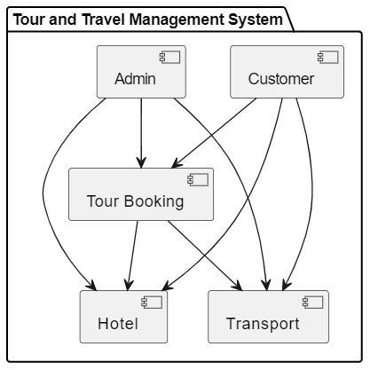

15

**5.3 UML Diagrams**

UML stands for Unified Modeling Language. UML is a standardized general-purpose modeling language in the field of object-oriented software engineering. The standard is managed, and was created by, the Object Management Group.

The goal is for UML to become a common language for creating models of object oriented computer software. In its current form UML is comprised of two major components: a Meta-model and a notation. In the future, some form of method or process may also be added to; or associated with, UML.

The Unified Modeling Language is a standard language for specifying, Visualization, Constructing and documenting the artifacts of software system, as well as for business modeling and other non-software systems.

The UML represents a collection of best engineering practices that have proven successful in the modeling of large and complex systems.

The UML is a very important part of developing objects-oriented software and the software development process. The UML uses mostly graphical notations to express the design of software projects.

**GOALS:**

The Primary goals in the design of the UML are as follows:

1. Provide users a ready-to-use, expressive visual modeling Language so that they can develop and exchange meaningful models.
2. Provide extendibility and specialization mechanisms to extend the core concepts.
3. Be independent of particular programming languages and development process.
4. Provide a formal basis for understanding the modeling language.
5. Encourage the growth of OO tools market.
6. Support higher level development concepts such as collaborations, frameworks, patterns and components.

7. Integrate best practices.

16

**CLASS DIAGRAM**

In software engineering, a class diagram in the Unified Modeling Language (UML) is a type of static structure diagram that describes the structure of a system by showing the system's classes, their attributes, operations (or methods), and the relationships among the classes. It explains which class contains information.

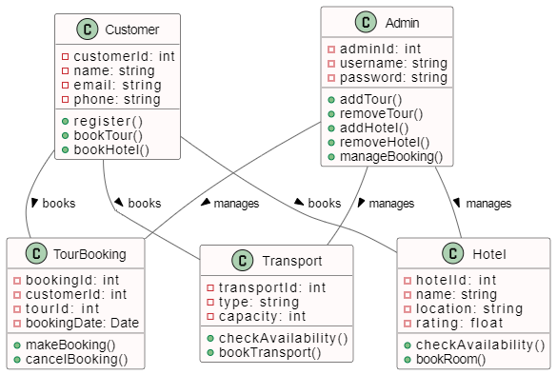

17

**USE CASE DIAGRAM**

A use case diagram in the Unified Modeling Language (UML) is a type of behavioral diagram defined by and created from a Use-case analysis. Its purpose is to present a graphical overview of the functionality provided by a system in terms of actors, their goals (represented as use cases), and any dependencies between those use cases. The main purpose of a use case diagram is to show what system functions are performed for which actor. Roles of the actors in the system can be depicted.

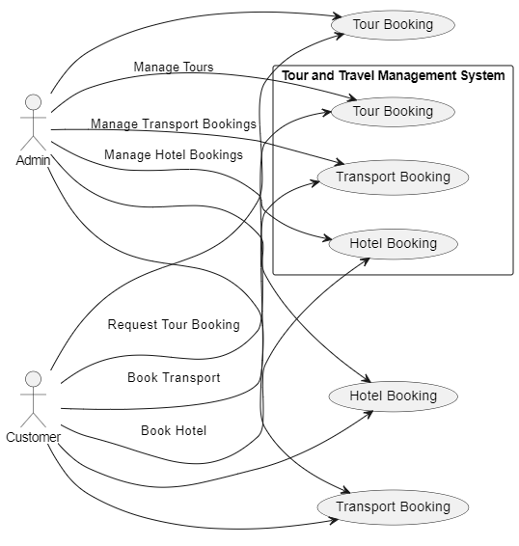

18

**SEQUENCE DIAGRAM**

A sequence diagram in Unified Modeling Language (UML) is a kind of interaction diagram that shows how processes operate with one another and in what order. It is a construct of a Message Sequence Chart. Sequence diagrams are sometimes called event diagrams, event scenarios, and timing diagrams.

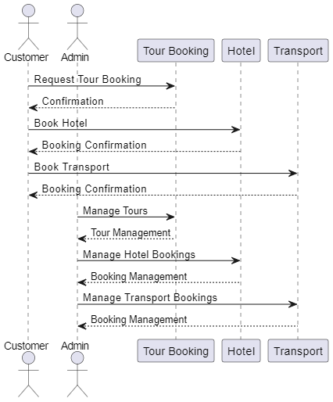

19

**Activity diagrams**

Activity diagrams are graphical representations of workflows of stepwise activities and actions[1] with support for choice, iteration and concurrency. In the Unified Modeling Language, activity diagrams are intended to model both computational and organizational processes (i.e., workflows), as well as the data flows intersecting with the related activities.[2][3] Although activity diagrams primarily show the overall flow of control, they can also include elements showing the flow of data between activities through one or more data stores.[citation needed]Activity diagrams are graphical representations of workflows of stepwise activities and actions[

1] with support for choice, iteration and concurrency. In the Unified Modeling Language, activity diagrams are intended to model both computational and organizational processes (i.e., workflows), as well as the data flows intersecting with the related activities.[2][3] Although activity diagrams primarily show the overall flow of control, they can also include elements showing the flow of data between activities through one or more data stores.[citation needed]

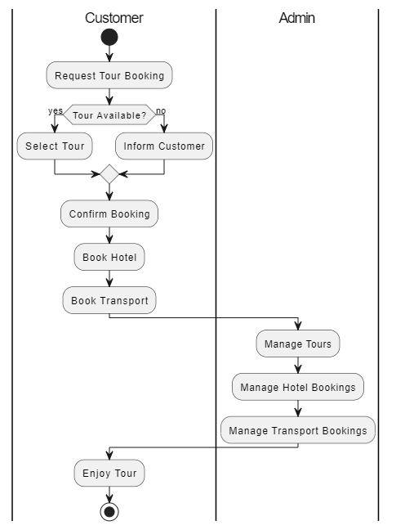

20

**Component Diagram**

The component diagram extends the information given in a component notation element. One way of illustrating the provided and required interfaces by the specified component is in the form of a rectangular compartment attached to the component element.[2] Another accepted way of presenting the interfaces is to use the ball-and-socket graphic convention. A provided dependency from a component to an interface is illustrated with a solid line to the component using the interface from a "lollipop", or ball, labelled with the name of the interface. A required usage dependency from a component to an interface is illustrated by a half-circle, or socket, labelled with the name of the interface, attached by a solid line to the component that requires this interface. Inherited interfaces may be shown with a lollipop, preceding the name label with a caret symbol. To illustrate dependencies between the two, use a solid line with a plain arrowhead joining the socket to the lollipop.[3]

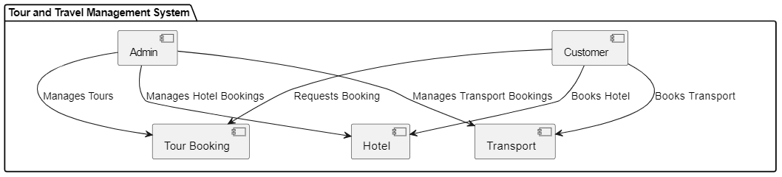

21

**Package Diagram**

Package diagram is UML structure diagram which shows structure of the designed system at the level of packages. The following elements are typically drawn in a package diagram: package, packageable element, dependency, element import, package import, package merge.

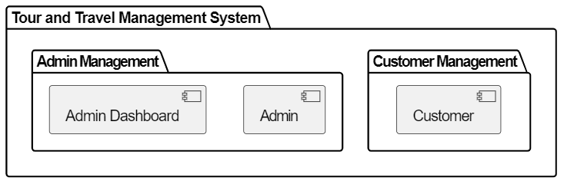

**Profile Diagram**

A Profile diagram is any diagram created in a «profile» Package. Profiles provide a means of extending the UML. They are based on additional stereotypes and Tagged Values that are applied to UML elements, connectors and their components.

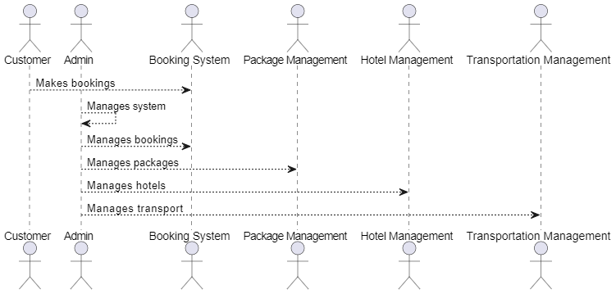

22

E-R DIAGRAM

ER diagrams are fundamental tools in database design and system analysis because they provide a clear, structured visualization of data relationships and dependencies, aiding in effective communication, design, and implementation of systems.

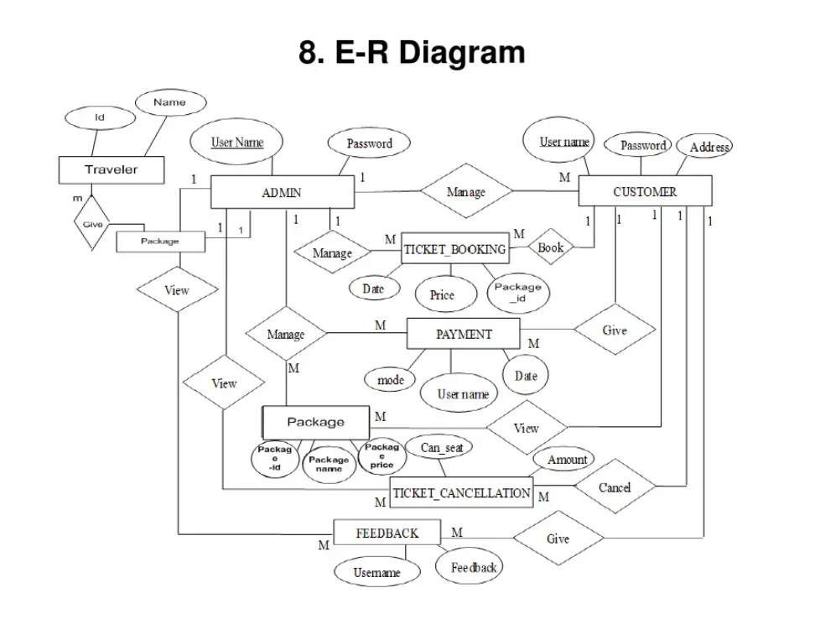

23

CHAPTER-6

IMPLEMENTATION

System components:

1. User Authentication: Allow users to register and log in to access their personalized travel plans.

2. Hotel Booking:

- Integrate with hotel APIs (e.g., Expedia, (link unavailable)) or create a database of available hotels.

- Allow users to search, filter, and book hotels based on preferences (location, dates, price, etc.).

3. Transportation:

- Integrate with transportation APIs (e.g., Google Maps, Rome2rio) or create a database of transportation options (flights, trains, car rentals, etc.).

- Allow users to search, filter, and book transportation based on preferences (departure/arrival locations, dates, price, etc.).

4. Places to Visit:

- Create a database of popular tourist attractions and activities (integrating with APIs like TripAdvisor or Google Places).

- Allow users to search, filter, and add places to visit to their itinerary.

5. Time Period:

- Allow users to specify their travel dates and duration.

- Generate a daily itinerary based on the user's preferences and booked hotels/transportation.

6. Itinerary Management:

- Display the user's itinerary in a calendar or list view.

- Allow users to edit, add, or remove activities, hotels, or transportation.

7. Payment Processing:

- Integrate with a payment gateway to securely process transactions.

24

Technical Requirements:

1. Frontend: Build the user interface using python

2. Backend: Use a programming language like Python, Ruby, or PHP to create the server-side logic, integrating with databases and APIs.

3. Database: Design a relational database (e.g., MySQL) or NoSQL database (e.g., MongoDB) to store user data, hotel information, transportation options, and places to visit.

4. APIs: Integrate with relevant APIs for hotel booking, transportation, and places to visit.

Additional Features:

1. Recommendations: Offer personalized suggestions based on user preferences and travel history.

2. Reviews: Allow users to rate and review hotels, transportation, and places to visit.

3. Notifications: Send reminders and updates to users about their itinerary and bookings.

4. Social Sharing: Enable users to share their itinerary on social media platforms.

25

**CHAPTER – 7**

**TECHNOLOGY DESCRIPTION**

Python is a general-purpose interpreted, interactive, object-oriented, and high-level programming language. An [interpreted language](https://en.wikipedia.org/wiki/Interpreted_language), Python has a design philosophy that emphasizes code [readability](https://en.wikipedia.org/wiki/Readability) (notably using [whitespace](https://en.wikipedia.org/wiki/Whitespace_character) indentation to delimit [code blocks](https://en.wikipedia.org/wiki/Code_block) rather than curly brackets or keywords), and a syntax that allows programmers to express concepts in fewer [lines of code](https://en.wikipedia.org/wiki/Source_lines_of_code) than might be used in languages such as [C++](https://en.wikipedia.org/wiki/C%2B%2B)or [Java](https://en.wikipedia.org/wiki/Java_(programming_language)). It provides constructs that enable clear programming on both small and large scales. Python interpreters are available for many [operating systems](https://en.wikipedia.org/wiki/Operating_system). [CPython](https://en.wikipedia.org/wiki/CPython" \o "CPython), the [reference implementation](https://en.wikipedia.org/wiki/Reference_implementation) of Python, is [open source](https://en.wikipedia.org/wiki/Open_source) software and has a community-based development model, as do nearly all of its variant implementations. Python is managed by the non-profit [Python Software Foundation](https://en.wikipedia.org/wiki/Python_Software_Foundation). Python features a [dynamic type](https://en.wikipedia.org/wiki/Dynamic_type) system and automatic [memory management](https://en.wikipedia.org/wiki/Memory_management). It supports multiple [programming paradigms](https://en.wikipedia.org/wiki/Programming_paradigm), including [object-oriented](https://en.wikipedia.org/wiki/Object-oriented_programming), [imperative](https://en.wikipedia.org/wiki/Imperative_programming), [functional](https://en.wikipedia.org/wiki/Functional_programming) and [procedural](https://en.wikipedia.org/wiki/Procedural_programming), and has a large and comprehensive [standard library](https://en.wikipedia.org/wiki/Standard_library)

## What is Python

## Python is a popular programming language. It was created by Guido van Rossum, and released in 1991.

**It is used for:**

* web development (server-side),
* software development,
* mathematics,
* system scripting.

### What can Python do

* Python can be used on a server to create web applications.
* Python can be used alongside software to create workflows.
* Python can connect to database systems. It can also read and modify files.
* Python can be used to handle big data and perform complex mathematics.
* Python can be used for rapid prototyping, or for production-ready software development.

### Why Python

* Python works on different platforms (Windows, Mac, Linux, Raspberry Pi, etc).
* Python has a simple syntax similar to the English language.
* Python has syntax that allows developers to write programs with fewer lines than some other programming languages.
* Python runs on an interpreter system, meaning that code can be executed as soon as it is written. This means that prototyping can be very quick.
* Python can be treated in a procedural way, an object-orientated way or a functional way.
* 26

### 

### Good to know

* The most recent major version of Python is Python 3, which we shall be using in this tutorial. However, Python 2, although not being updated with anything other than security updates, is still quite popular.
* In this tutorial Python will be written in a text editor. It is possible to write Python in an Integrated Development Environment, such as Thonny, Pycharm, Netbeans or Eclipse which are particularly useful when managing larger collections of Python files.

### Python Syntax compared to other programming languages

* Python was designed for readability, and has some similarities to the English language with influence from mathematics.
* Python uses new lines to complete a command, as opposed to other programming languages which often use semicolons or parentheses.
* Python relies on indentation, using whitespace, to define scope; such as the scope of loops, functions and classes. Other programming languages often use curly-brackets for this purpose.

**Python Install**

Many PCs and Macs will have python already installed.

To check if you have python installed on a Windows PC, search in the start bar for Python or run the following on the Command Line (cmd.exe):

C:\Users\Your Name>python --version

To check if you have python installed on a Linux or Mac, then on linux open the command line or on Mac open the Terminal and type:

python --version

If you find that you do not have python installed on your computer, then you can download it for free from the following website: https://www.python.org/

Python Quick start

Python is an interpreted programming-language, this means that as a developer you write Python (.py) files in a text editor and then put those files into the python interpreter to be executed.

27

The way to run a python file is like this on the command line:

C:\Users\Your Name>python helloworld.py

Where "helloworld.py" is the name of your python file.

Let's write our first Python file, called helloworld.py, which can be done in any text editor.

helloworld.py

print("Hello, World!")

Simple as that. Save your file. Open your command line, navigate to the directory where you saved your file, and run:

C:\Users\Your Name>python helloworld.py

The output should read:

Hello, World!

Congratulations, you have written and executed your first Python program.

The Python Command Line

To test a short amount of code in python sometimes it is quickest and easiest not to write the code in a file. This is made possible because Python can be run as a command line itself.

Type the following on the Windows, Mac or Linux command line:

C:\Users\Your Name>python

Or, if the "python" command did not work, you can try "py":

C:\Users\Your Name>py

From there you can write any python, including our hello world example from earlier in the tutorial:

C:\Users\Your Name>python

28

Python 3.6.4 (v3.6.4:d48eceb, Dec 19 2017, 06:04:45) [MSC v.1900 32 bit (Intel)] on win32

Type "help", "copyright", "credits" or "license" for more information.

>>>print("Hello, World!")

Which will write "Hello, World!" in the command line:

C:\Users\Your Name>python

Python 3.6.4 (v3.6.4:d48eceb, Dec 19 2017, 06:04:45) [MSC v.1900 32 bit (Intel)] on win32

Type "help", "copyright", "credits" or "license" for more information.

>>>print("Hello, World!")

Hello, World!

Whenever you are done in the python command line, you can simply type the following to quit the python command line interface:

exit()

**Virtual Environments and Packages**

**Introduction**

Python applications will often use packages and modules that don’t come as part of the standard library. Applications will sometimes need a specific version of a library, because the application may require that a particular bug has been fixed or the application may be written using an obsolete version of the library’s interface.

This means it may not be possible for one Python installation to meet the requirements of every application. If application A needs version 1.0 of a particular module but application B needs version 2.0, then the requirements are in conflict and installing either version 1.0 or 2.0 will leave one application unable to run.

The solution for this problem is to create a virtual environment, a self-contained directory tree that contains a Python installation for a particular version of Python, plus a number of additional packages.

29

**Using the Python Interpreter**

**Invoking the Interpreter**

The Python interpreter is usually installed as /user/local/bin/python3.8 on those machines where it is available; putting /user/local/bin in your Unix shell’s search path makes it possible to start it by typing the command:

python3.8

to the shell. 1 Since the choice of the directory where the interpreter lives is an installation option, other places are possible; check with your local Python guru or system administrator. (E.g., /user/local/python is a popular alternative location. On Windows machines where you have installed Python from the Microsoft Store, the python3.8 command will be available. If you have the py.exe launcher installed, you can use the py command. See Excursus: Setting environment variables for other ways to launch Python.

Typing an end-of-file character (Control-D on Unix, Control-Z on Windows) at the primary prompt causes the interpreter to exit with a zero exit status. If that doesn’t work, you can exit the interpreter by typing the following command: quit().

The interpreter operates somewhat like the Unix shell: when called with standard input connected to a tty device, it reads and executes commands interactively; when called with a file name argument or with a file as standard input, it reads and executes a script from that file.

A second way of starting the interpreter is python -c command [arg] ..., which executes the statement(s) in command, analogous to the shell’s -c option. Since Python statements often contain spaces or other

characters that are special to the shell, it is usually advised to quote command in its entirety with

single quotes.

Some Python modules are also useful as scripts. These can be invoked using python -m module [are] ..., which executes the source file for module as if you had spelled out its full name on the command line.

When a script file is used, it is sometimes useful to be able to run the script and enter interactive mode afterwards. This can be done by passing -i before the script. All command line options are described in Command line and environment.

30

Argument Passing

When known to the interpreter, the script name and additional arguments thereafter are turned into a list of strings and assigned to the rage variable in the sys module. You can access this list by executing import sys. The length of the list is at least one; when no script and no arguments are given, siamang[0] is an empty string. When the script name is given as '-' (meaning standard input), siamang[0] is set to '-'. When -c command is used, siamang[0] is set to '-c'. When -m module is used, siamang[0] is set to the full name of the located module. Options found after -c command or -m module are not consumed by the Python interpreter’s option processing but left in siamang for the command or module to handle.

Interactive Mode

When commands are read from a tty, the interpreter is said to be in interactive mode. In this mode it prompts for the next command with the primary prompt, usually three greater-than signs (>>>); for continuation lines it prompts with the secondary prompt, by default three dots (...). The interpreter prints a welcome message stating its version number and a copyright notice before printing the first prompt:

$ python3.8

Python 3.8 (default, Sep 16 2015, 09:25:04)

[GCC 4.8.2] on Linux

Type "help", "copyright", "credits" or "license" for more information.

>>>

Continuation lines are needed when entering a multi-line construct. As an example, take a look at this if statement:

>>>

>>>the _world _is _flat = True

>>>if the_ world _is _flat:

... print("Be careful not to fall off!")

...

Be careful not to fall off!

31

**CHAPTER – 8**

**CODING**

**Source code**

import tkinter as tk

from tkinter import ttk

from PIL import Image, ImageTk

# Function to open booking page

def open_booking_page():

print("Opening Booking Page")

# Add functionality to open booking page here

def open_booking_page():

def open_reservation_page():

print("Opening About Temple Page")

# Add functionality to open reservation page here

# Function to open profile page

def open_profile_page():

print("Opening Contact Us Page")

# Add functionality to open profile page here

# Create main window

root = tk.Tk()

root.title("Exploration Of New Cities")

32

# Load background image

background_image = Image.open("travel.jpg")

image_resized = background_image.resize((1700, 1000))

# Resize image as needed

background_photo = ImageTk.PhotoImage(image_resized)

# Create a label with the background image

background_label = tk.Label(root, image=background_photo)

background_label.place(x=10, y=10, relwidth=1, relheight=1)

# Add welcome message

welcome_label = tk.Label( text="Exploration Of New Cities", font=("helvetica", 35, "bold"), background=("lavender"),fg='black')

welcome_label.pack(pady=150,padx=10)

# Create buttons for different pages

customer_button = tk.Button( text="Customer",font=("times new roman", 18, "bold"),fg='black',bg='white',command=open_booking_page)

customer_button.pack(pady=10, padx=10, ipadx=20)

tourbooking_button = tk.Button( text="Tour Booking",font=("times new roman", 18, "bold"),fg='black',bg='white',command=open_booking_page)

tourbooking_button.pack(pady=10, padx=10, ipadx=20)

# Start the main loop

root.mainloop()

33

**CHAPTER – 9**

**SYSTEM TESTING**

**9.1 Testing Methodologies**

The purpose of testing is to discover errors. Testing is the process of trying to discover every conceivable fault or weakness in a work product. It provides a way to check the functionality of components, sub assemblies,assemblies and/or a finished product It is the process of exercising software with the intent of ensuring that the Software system meets its requirements and user expectations and does not fail in an unacceptable miner. There are various types of test. Each test type addresses a specific testing requirement.

### 9.2 TYPES OF TESTS

**Unit testing**

Unit testing involves the design of test cases that validate that the internal program logic is functioning properly, and that program inputs produce valid outputs. All decision branches and internal code flow should be validated. It is the testing of individual software units of the application .it is done after the completion of an individual unit before integration. This is a structural testing, that relies on knowledge of its construction and is invasive. Unit tests perform basic tests at component level and test a specific business process, application, and/or system configuration. Unit tests ensure that each unique path of a business process performs accurately to the documented specifications and contains clearly defined inputs and expected results.

**Integration testing**

Integration tests are designed to test integrated software components to determine if they actually run as one program. Testing is event driven and is more concerned with the basic outcome of screens or fields. Integration tests demonstrate that although the components were individually satisfaction, as shown by successfully unit testing, the combination of components is correct and consistent. Integration testing is specifically aimed at exposing the problems that arise from the combination of components.

***Functional test***

Functional tests provide systematic demonstrations that functions tested are available as specified by the business and technical requirements, system documentation, and user manuals.

Functional testing is centered on the following items:

Valid Input : identified classes of valid input must be accepted.

Invalid Input : identified classes of invalid input must be rejected.

Functions : identified functions must be exercised.

Output : identified classes of application outputs must be exercised.

34

Systems/Procedures : interfacing systems or procedures must be invoked.

Organization and preparation of functional tests is focused on requirements, key functions, or special test cases. In addition, systematic coverage pertaining to identify Business process flows; data fields, predefined processes, and successive processes must be considered for testing. Before functional testing is complete, additional tests are identified and the effective value of current tests is determined.

**System Test**

System testing ensures that the entire integrated software system meets requirements. It tests a configuration to ensure known and predictable results. An example of system testing is the configuration-oriented system integration test. System testing is based on process descriptions and flows, emphasizing pre-driven process links and integration points.

**Unit Testing**

Unit testing is usually conducted as part of a combined code and unit test phase of the software lifecycle, although it is not uncommon for coding and unit testing to be conducted as two distinct phases.

**Test strategy and approach**

Field testing will be performed manually and functional tests will be written in detail.

**Test objectives**

* All field entries must work properly.
* Pages must be activated from the identified link.
* The entry screen, messages and responses must not be delayed.

**Features to be tested**

* Verify that the entries are of the correct format
* No duplicate entries should be allowed
* All links should take the user to the correct page.

**Integration Testing**

# Software integration testing is the incremental integration testing of two or more integrated software components on a single platform to produce failures caused by interface defects.

The task of the integration test is to check that components or software applications, e.g. components in a software system or – one step up – software applications at the company level – interact without error.

**Test Results:** All the test cases mentioned above passed successfully. No defects encountered.

35

CHAPTER-10

RESULT AND OUTPUT SCREENS

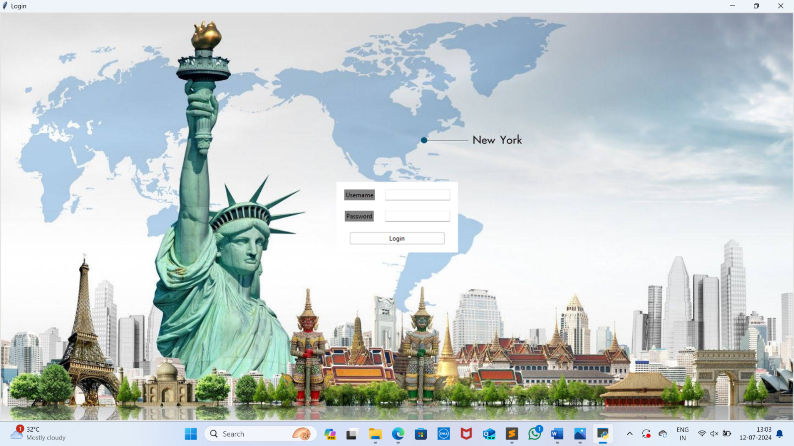

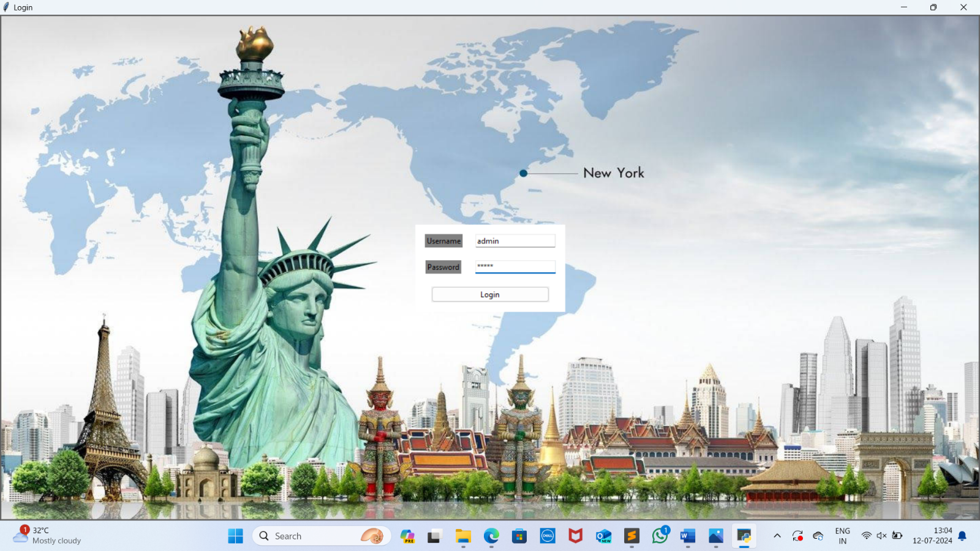

36

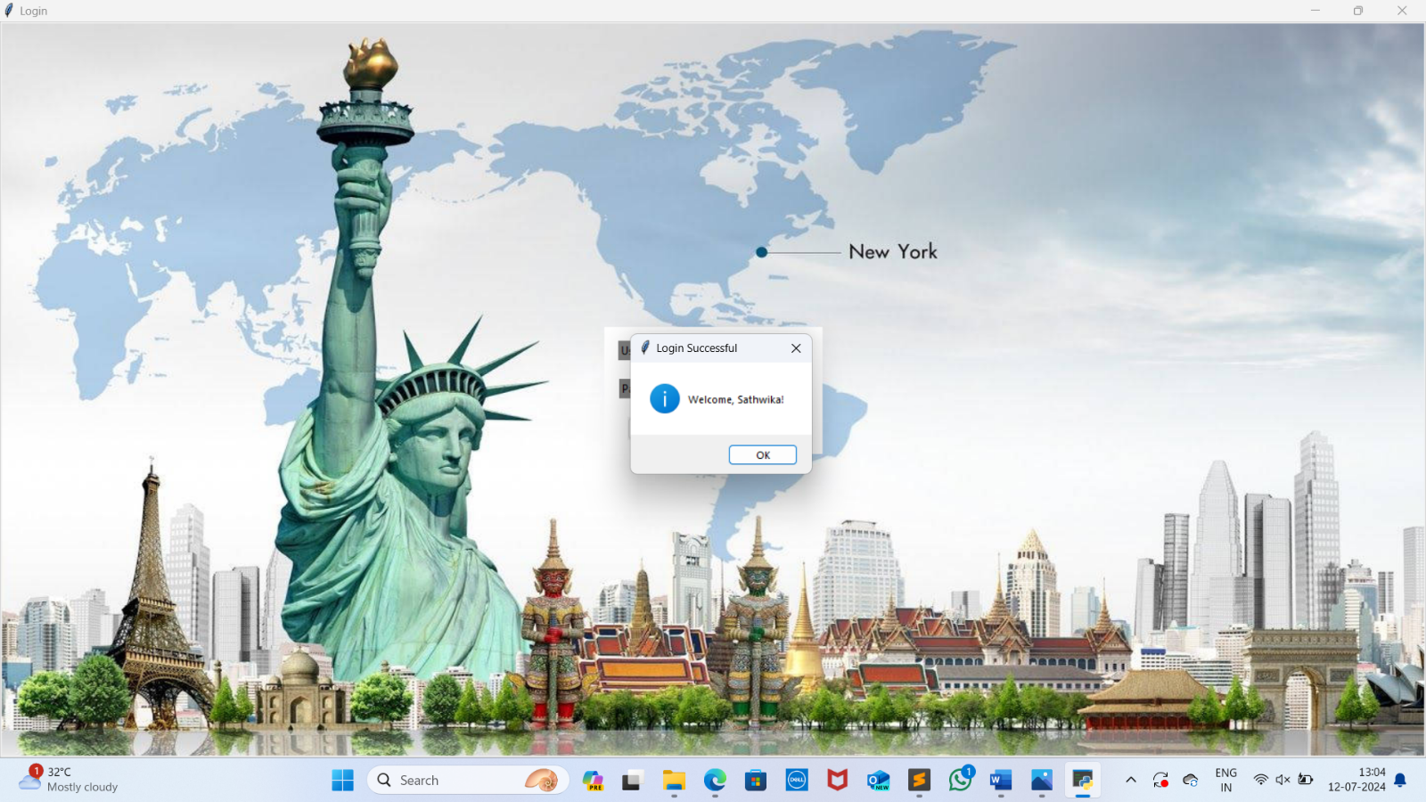

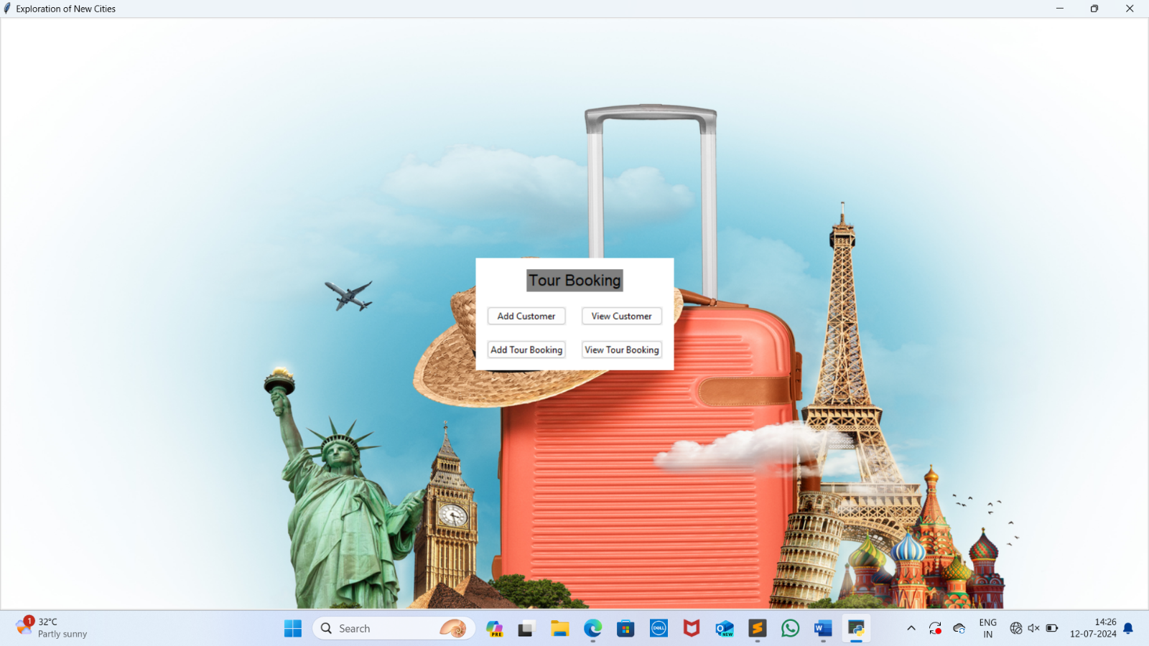

37

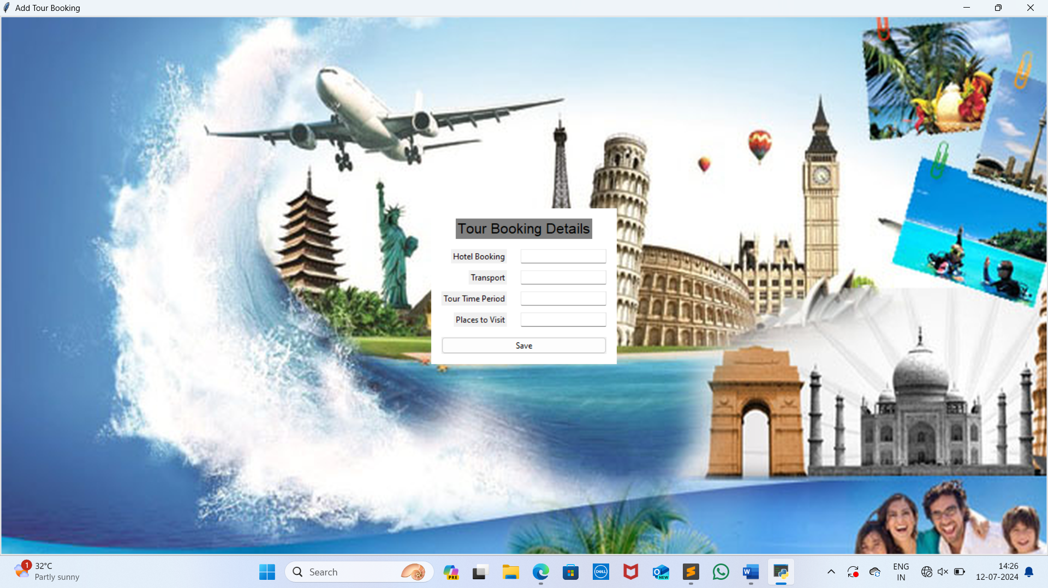

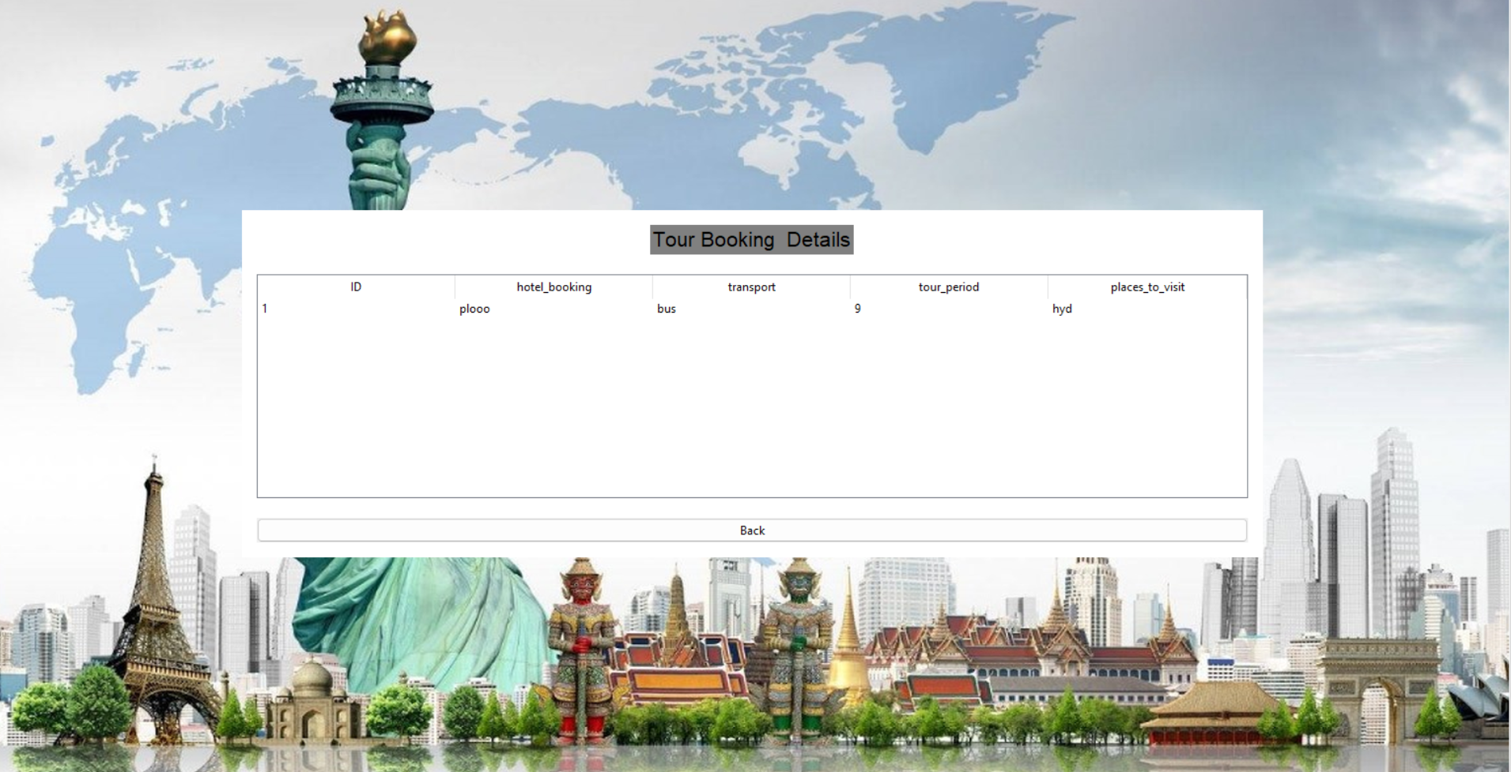

38

**CHAPTER – 11**

**Conclusion**

In conclusion, the development and implementation of the Tour and Travel Management System represent a significant step forward in enhancing efficiency, transparency, and customer satisfaction within the travel industry. Throughout the course of this project, several key objectives were achieved:

1. **Enhanced Efficiency**: The system successfully streamlines booking processes, itinerary planning, and resource allocation, reducing manual errors and improving overall operational efficiency.
2. **Improved Customer Experience**: By providing a user-friendly interface and comprehensive information access, the system enhances the overall experience for travelers, allowing for easier bookings, real-time updates, and personalized services.
3. **Effective Resource Management**: With features such as automated scheduling, inventory management, and financial tracking, the system enables better resource allocation and cost management for travel agencies and operators.
4. **Data Security and Integrity**: Robust security measures have been implemented to safeguard sensitive customer information and transactional data, ensuring trust and reliability in the system.
5. **Scalability and Adaptability**: Designed with scalability in mind, the system can accommodate future growth and technological advancements in the travel industry, staying relevant and effective in a dynamic market environment.
6. **Business Insights and Decision Making**: Through integrated reporting and analytics tools, the system provides valuable insights into customer preferences, market trends, and operational performance, empowering management to make informed decisions.

In essence, the Tour and Travel Management System not only meets the current demands of the travel industry but also lays a foundation for future innovations and improvements. By leveraging technology to streamline processes and enhance customer interactions, the system sets a benchmark for excellence in travel management solutions. As the project concludes, it is clear that the benefits accrued from this system will continue to drive positive outcomes for both service providers and traveler’s alike, contributing to a more seamless and enjoyable travel experience globally.

FUTURE ENHANCEMENT

These future enhancements aim to not only keep the Tour and Travel Management System competitive but also to anticipate and meet the evolving needs and expectations of travelers and industry stakeholders in an increasingly digital and interconnected world.

Top of Form

Bottom of Form

39

CHAPTER-12

REFERENCES

• **Introduction to Travel Management Systems**:

* Information Systems for Business and Beyond by David T. Bourgeois
* Principles of Information Systems by Ralph M. Stair and George W. Reynolds

• **Technological Framework and Architecture**:

* Enterprise Architecture Planning: Developing a Blueprint for Data, Applications, and Technology by Steven H. Spewak
* Software Architecture in Practice by Len Bass, Paul Clements, and Rick Kazman

• **Database Management**:

* Database Management Systems by Raghu Ramakrishnan and Johannes Gehrke
* Fundamentals of Database Systems by Ramez Elmasri and Shamkant B. Navathe

• **Security and Privacy**:

* Cryptography and Network Security: Principles and Practice by William Stallings
* Network Security Essentials: Applications and Standards by William Stallings

• **User Interface Design**:

* Designing the User Interface: Strategies for Effective Human-Computer Interaction by Ben Shneiderman and Catherine Plaisant
* The Design of Everyday Things by Don Norman

• **Mobile Application Development**:

* Mobile Computing by Asoke K. Talukder and Hasan Ahmed
* Mobile Application Development: Challenges and Best Practices by Kenneth R. Rosen, Arnold Robbins, and Stephen Prata

40

**Project Management and Software Development Methodologies**:

* Agile Project Management: Creating Innovative Products by Jim Highsmith
* Software Engineering: A Practitioner's Approach by Roger S. Pressman

**Artificial Intelligence and Machine Learning** (if applicable):

* Artificial Intelligence: A Modern Approach by Stuart Russell and Peter Norvig
* Machine Learning Yearning by Andrew Ng

**Data Analytics and Business Intelligence**:

* Business Intelligence Guidebook: From Data Integration to Analytics by Rick Sherman
* Data Analytics Made Accessible by Anil Maheshwari

**Industry Reports and White Papers**:

* Reports from organizations like Gartner, Forrester, or Deloitte on trends in travel technology and management systems.
* White papers or case studies from leading travel management software providers or industry associations.

Top of Form

Bottom of Form

41